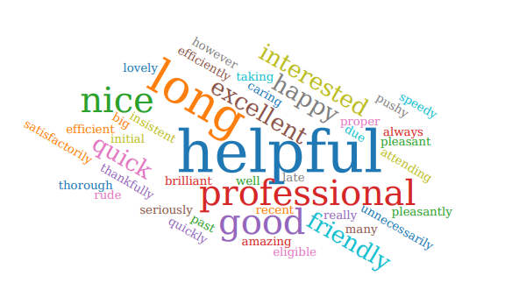

Feedback from Iplato –
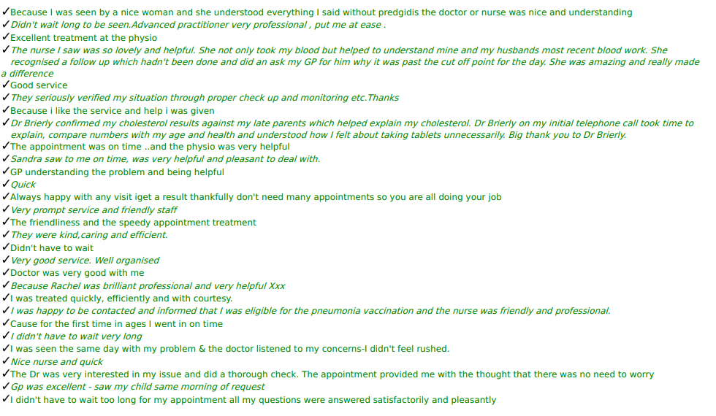

Feedback other –
F & F feedback - nurse Jenny was amazing, very professional, friendly, very helpful and knowledgeable.
F & F feedback - Taylor on nurse reception was very helpful and pleasant.
F & F feedback - GP was so helpful and explained everything about my mum's scans - thank you so much.
F & F feedback - receptionist are always nice and happy with the service from the practice.
F & F feedback - very thankful for the National Health service and all the staff at the surgery and would be lost without you.
F & F feedback - Doctor carlin who I saw has provided fantastic care to my son, we have seen her twice over the last month and she is so professional, kind, caring and is a credit to the practice.
F & F feedback - I have had a smear with the nurse she was very informative, made me feel relaxed and explained everything thoroughly thank you.
Patient rang reception to say the doctor (JP) who she saw said he was lovely and would be happy to see him again.
Patient contacted the practice to say thanks for referring her to gynaecology with suspected ovarian cancer, the diagnosis was correct. She was referred promptly with the correct bloods along with an urgent USS so the consultant could act promptly. Patient is now in full remission and wanted to thank clinician Diane) for all she had done to ensure her recovery and care.
Patient brought in chocolate for the gp (Dr Brierley) she had seen.
patient rang to say he has never had an issue with the staff here - always 1st class and he is very happy here - he had an appointment but could not reply via text for the feedback.
patient rang today and wanted to express how grateful he is for the care and service he receives – He saw Diane yesterday who he said was very thorough and said he always gets an appointment within a few days. In his words “Staff and service are top class.”
Patient rang to say she was very happy with the home visit she received from the gp (Dr Misterek) - she was very happy and pleased as punch.

Feedback from accurex –
Caring and efficient staff.
The receptionist team are very efficient and helpful. The GP I saw it was helpful.
The receptionist I spoke to was very helpful and went out of her way to help me, I also spoke to the doctor on the phone and again I felt I was listening to, and I felt the doctor also went out there way to also book me in the next day as she decided that I would benefit more with a face to face appointment. I left my appointment with the doctor feeling like I was really looked after and treated with kindness and respect.
Visited Naysha for an asthma review and she was outstanding. She previously highlighted my unusual heartbeat and then with Dr Brierley's help with blood tests and scans etc, they both have been exceptional in their professionalism and expertise.
The nurse who I personally saw was brilliant really made me feel listened to and I came away positive which hasn't been the case in all my dealings with your practice. But the nurse who I seen Pamela I believe her name was an absolute credit to your surgery.
Excellent care from the practice Nurse Sister Sandra Myers. I could not fault the care and attention she gave.
My request was dealt with swiftly with a same day appointment.
Very efficient service. Allocated same day appointment. Doctor was very helpful & attentive to all my concerns. Left feeling much better & have already received my appointment to be seen on the 2 weeks wait. Thank you so much.
My appointment was on time yesterday, and the lady who did my blood test was very nice.
Receptionist very helpful and friendly. Doctor very patient and helpful
Dr Wilkinson was excellent, and reception was very helpful.
Saw practice nurse, Rachel, who was very professional, very efficient and went out of her way to help.
Generally, a good service, especially advantageous to have the physio on site.
Requested a appointment had one within 20 mins on the same day
Nurse was excellent with my newborn, very patient and compassionate.
I felt that I was listened to, not hurried and therefore able to feel relaxed.
ON THIS OCCASION Dr Mistrek was,Brilliant and in the past also.
I told to physiotherapist I have high Blood pressure and she did great job consulting this with nurse and getting me medicine to that.
Staff very understanding of my Aphasia mobility difficulties.
I saw Dr misteik with eye problem and I am now sat in Boston house eye clinic could not have been any quicker.
Easy to use My gp and get telephone consultation or appointment. Seen timely.
Was seen promptly and pleasant staff members.
Dr Siobhan Carlin was brilliant! Professional, understanding, kind & caring. Thank you for all your wonderful help with Ethan! You’ve been amazing! Karen (Mum)
Dr Diane Barton was amazing. So calm and kind. I really liked her. She made the experience a good one.
All the staff are always so helpful and friendly. Nurse Jenny who I saw yesterday was so informative and give me some information on carers.
The receptionist was helpful and sorted out my emergency, I felt I had great care as the GP requested to see me face to face after my emergency request. Dr Carlin was thorough, explained everything to me was very kind and I felt safe.
Dr Gupta was very thorough.
The practice is run well.

