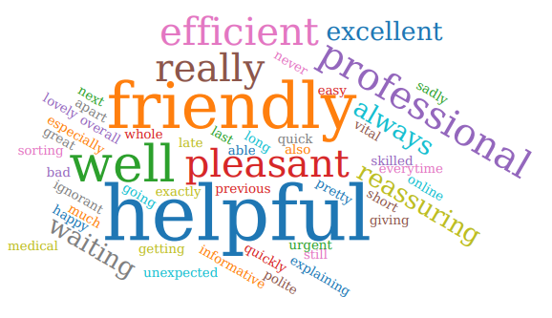
General feedback
F&F feedback - receptionist Cheryl helped with my ask my gp, she was very helpful. Would like to pass on my heartfelt thanks.

F& F feedback - receptionists Cheryl assistance was greatly appreciated, her care and compassion were second to none.

Patients’ son came to front desk wanting to express thanks for seeing his father that morning, really appreciated a lot of thing got sorted for his father - wanted to pass on thanks.

Phone call from patient’s wife to express thanks for the kindness and patience to the receptionist (Lauren) who helped sort her husband’s medication out - she wanted to ring and give praise as she realises how much grief receptionist get and wanted to give some nice feedback which is deserved. verbally - Diana Jordan

Chocolate bought for member of staff - Lynn Fazackerley with a note attached saying thank you.

Patient rang the practice and informed member of staff Dawn they were very helpful, and all the team are outstanding.

thank you card to nurse Rachel - thank you so much for everything you do and have done for me - you're a incredible nurse and a credit to the practice.

F & F feedback - reordering medication and staff member Cheryl helped with the log on system, she was great, and nothing was a problem - great asset to the team thank you very much.

F & F feedback - came in quite distressed with high blood pressure possible panic attack and team member Cheryl was very helpful and caring and went the extra mile to assist.

F & F feedback - ANP Melissa seen was very professional and knowledgeable.

Thank you, card - thank you so much for all the help you gave me with my daughter ear splint nurse Rachel- it was so kind of you.

Ask my gp - Dr Brierley is amazing, listens and is so easy to talk too. Professional & calming. I came off the call feeling so much better. Thank you, an asset to your team.

Feedback from IPlato
Staff are friendly and informative and a mistake by them last Friday was quickly solved.
I was seen on time and the nurse was very pleasant and professional.
Appointment was on time and was treated well.
GP and staff was very helpful.
Really good service.
Because my overall experience was good
The short time it took for the appointment plus the friendliness of the staff.
Appointment time was exactly on time, no long wait and efficient good services.
My well woman appointment this morning was very good and dealt with on time. Pam Myers was able to also assist with an urgent appointment that had been missed Thank you.
Rachel was the best Previous smears were very painful.
Always helpful staff.
Appointment was on time and conducted in a very friendly but professional manner.
Nurse very helpful and explained things very well.
Better service than other surgeries.
Really friendly and helpful staff.
Because in my own opinion apart from being a bit late going in I feel that score is the right one.
Nurse was very reassuring explaining everything especially why I needed to monitor my blood pressure for the next week. She was easy to talk to, with a lovely attitude.
Staff polite & helpful.
Never had a problem there.
Great service.
No issues with getting an appointment, same day as well which was unexpected. Pretty good service, only downfall really is the lack of parking which there's not much that can be done to fix it sadly.
Good service today My experience with the practice as a whole has been good.
I saw Pamela Myers, practice nurse yesterday and she was very good giving me advice what I needed and sorting my prescription for me.
On time and very pleasant and did what was needed Staff were quick and efficient.
The nurse that I saw was excellent and treated me in a very pleasant and professional manner.
Did what you needed to do.
Good captured the experience.
communication is very good and for our medical problems gp online today was excellent.
Happy with my appointment.
Staff friendly and efficient Staff are always friendly and helpful.
Because I thought I had a very good experience.

