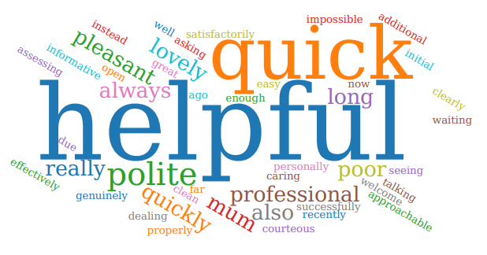

Patient comments:

*Thank you letter - saw nurse Jenny given a new inhaler - started to feel much better I can walk for 10-15 mins nonstop now - thanks you very much.

*F & F feedback - very thankful for all the help from the staff.

*F & F feedback thank you for your continued help and support.

*F & F feedback - thanks you for all your help.

*F&F feedback - doctor Musarraf was absolutely brilliant he listened, very caring really took his time with my son - would see this doctor again.

*F & F feedback - receptionist was really helpful and gave me time to explain the situation.

*F & F feedback - very grateful for everything done at the surgery and excellent service from the physio.

*F & F feedback - excellent prompt service, surgery staff do an excellent job.

*Ask my gp feedback - nurse Caroline I saw was amazing - I don't like doing my asthma reviews but she has changed my mind as she gave me good advice and explained everything clearly.

*Email from patient - the man who was on the desk is lovely and very helpful.

*verbally patient said everyone is fantastic at Beech hill , since being discharged from hospital she has forgotten to reauthorise her meds twice and each time it has been sorted straight away with no problem.

*Because you're quick and for me personally I use you a lot I feel welcome I did not have to wait long, and the procedure was completed satisfactorily.
*Professional care Very helpful AND POLITE Friendly helpful staff as always
*Prompt triaging and appointment. Good consultation.
*Because she explained everything to me and also very courteous to me
*No waiting time, very efficient and lovely staff , offered good advice x Nurse was very helpful.
The receptionists where really friendly and helpful and Dr Wilkinson was really good. Everything was explained clearly Very helpful informative and thorough.
*Very efficient, helpful & polite staff.
*In & out for my blood test this morning. Also the doctor I saw 2 weeks ago was very thorough, helpful & genuinely concerned about my condition
*Good
* I have only recently joined the practice but so far I have found everyone associated with the practice from the receptionists, nurses and doctors very helpful and approachable
*Quick efficient service from nurse Rachel
*Got an appointment quick today when needed and felt that I was listened to and satisfied with the outcome
*The nurse who did my bloods was quick, efficient, and lovely
*Quick, efficient, thorough, friendly, caring....all great. Thank you
* I didn't have to wait. The nurse was friendly and very efficient.
*Dealing with the practice was very easy. Initial enquiry was via AskMyGP which suits me as it leaves it up to the doctor to determine if and how quickly an appointment is needed. Appointment booked at a time to suit me, again via a system so doesn't clog up practice staff time. Follow up appointment with phlebotomist took 5 mins so very quick and efficient.
* Nurse was very pleasant, on time and listened to me
*Was seen on time and got some help I needed for mum as her carer I was treated well. He listened to me properly & didn't rush me.
*They are very helpful and have always responded quickly and effectively to my queries and concerns.
*Helpful service given by Pam M to fit my INR services in with holiday.
*My service today was friendly, quick and professional. Everything you'd want from a practice
* This morning's appointment with the nurse was on time, friendly and she provided me with additional information in a very pleasant manner
* I find since covid I am less dependent on seeing a doctor, talking on the phone initially suits me. I have not had to wait for information.
* The doctor was very polite and thorough

